- Database Name : YoutubeCloneDB
- Collections name :
- users
- videos
- chennals
- comments

1.Users collections store the user’s information like registration information and then login credential.
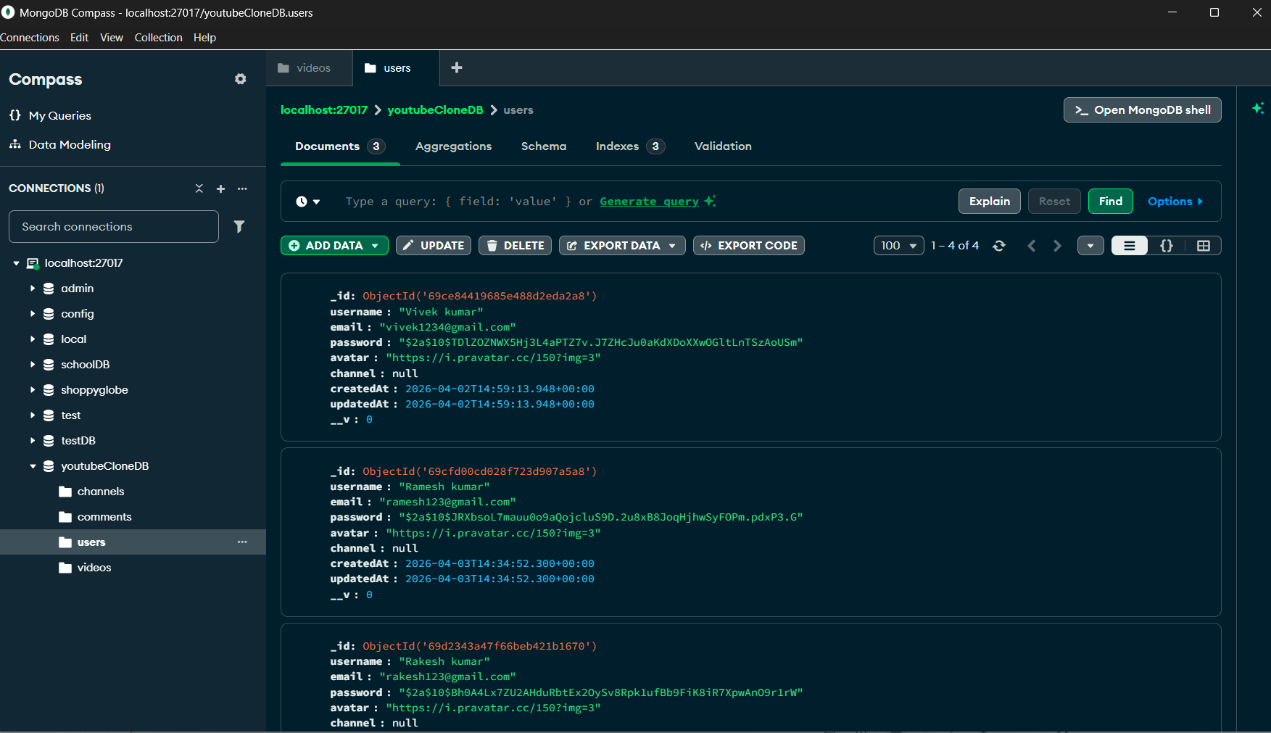

2 . videos collections store the videos related informations.
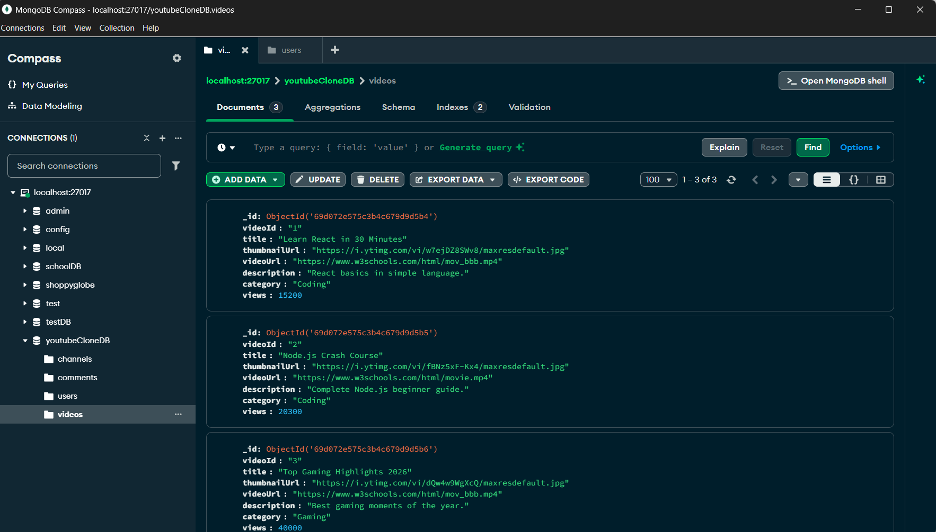

- chennals collection store the related to the channel information like
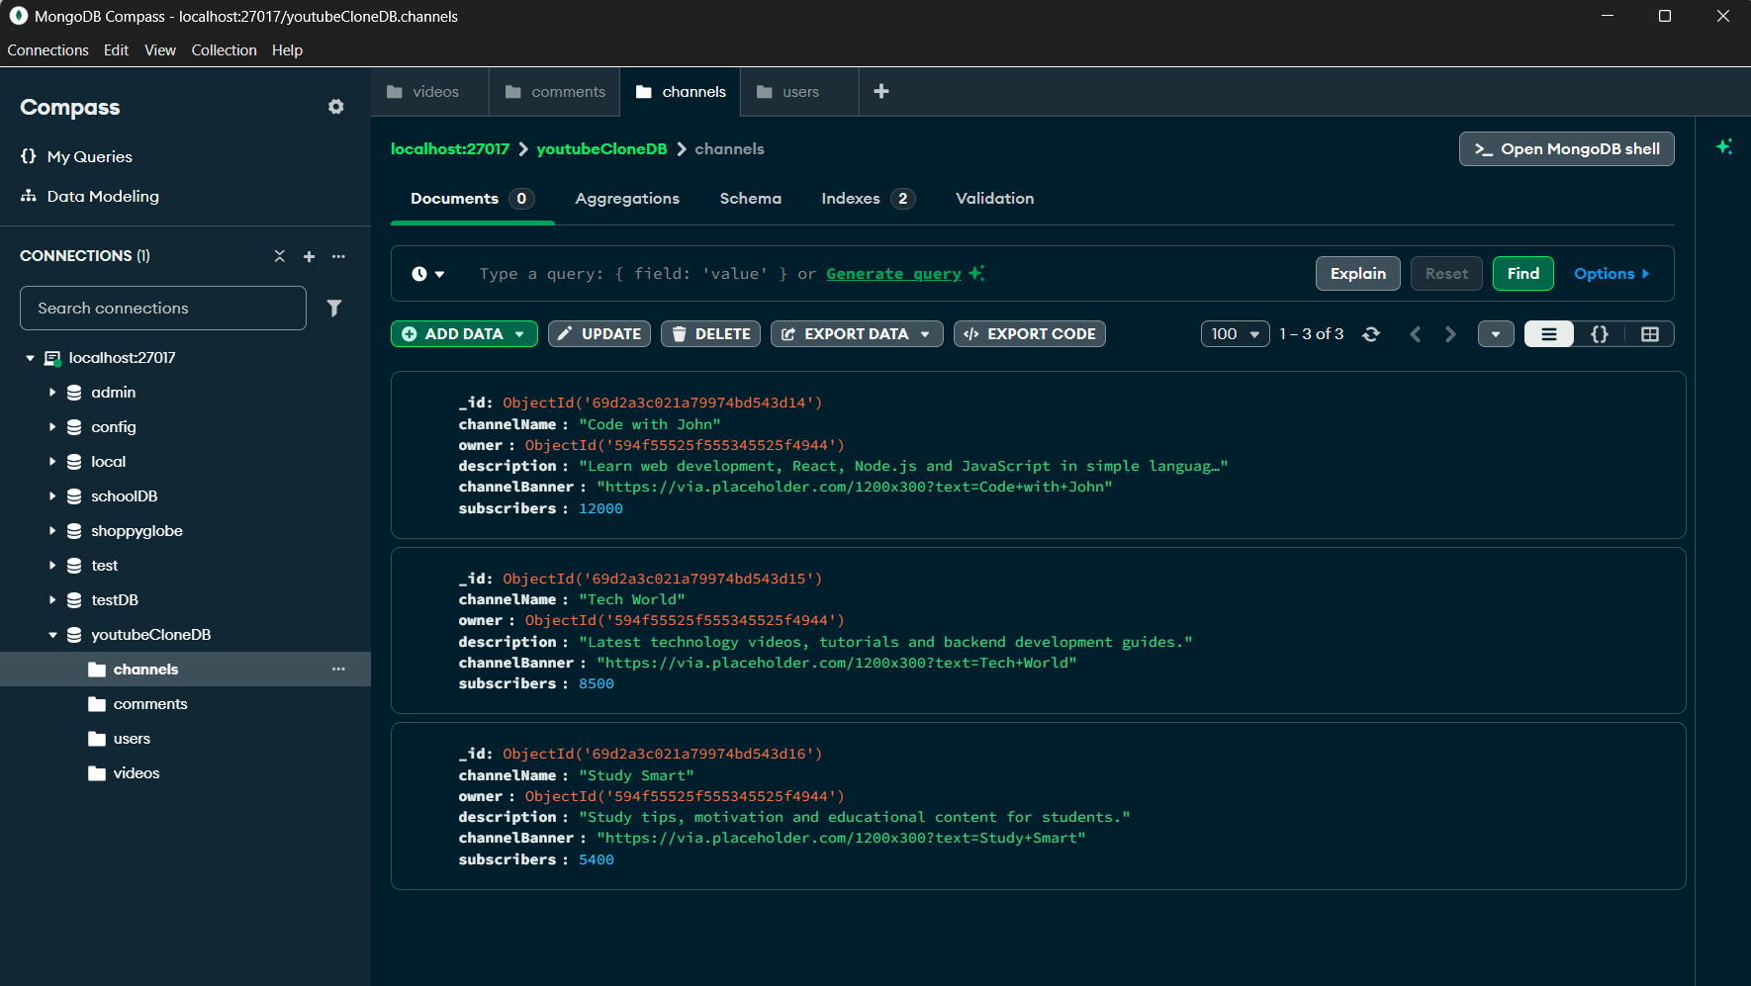

- Comments collection store the users comments related information ,
